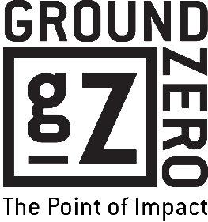
Community Relations Director
Responsibility Description

Summary

The Community Relations Director engages the business community to partner with Ground Zero and sponsor events. This enthusiastic, organized communicator has strong sales skills and the ability to connect with individuals and businesses to secure designated number of Dragon Boat Captains, sponsorships and ads to meet financial benchmarks. The director also uses excellent people skills to encourage and motivate individual ministry partners and recruit new partners for the ministry.

Reports to: President

Position-Related Responsibilities

- engage with staff to create, plan and implement exciting outreach ministry to teenagers
- attend and actively assist in all ministry outreach events

Sponsorships
- develop creative sponsorship packages to grow existing advancement efforts and create new efforts
- identify, recruit, and secure the designated number of sponsors/ads for specified events and projects
- ensure Ground Zero fulfills our commitment to sponsors in print, online, email, media, advertising and signage
- ensure the ministry acknowledges sponsors at events and follows up with thank you packets
- identify and introduce new business partners to the ministry
- nurture existing business partners with invitations to events, print and online resources, and face-to-face meetings
- communicate with local civic groups and the Myrtle Beach Area Chamber of Commerce to educate them about GZ and offer opportunities to partner together
Advancement Events
- direct fall dinner event to build awareness in the community, recruit a designated number of monthly partners, and meet its fundraising goal
- oversee all fundraising aspects of Dragon Boat Festival following a written, detailed plan to reach financial goals
- recruit designated number of Dragon Boat Captains for the festival (May – January)
- nurture designated number of Dragon Boat Captains following a written, detailed plan (monthly contacts May – December / Captain’s Dinners and heavy nurture January – April)
- secure designated number of food and other vendors for Dragon Boat Festival and other events as necessary (September – December)
- secure designated number of event sponsors (May – August)
- secure gift packets and incentives for Dragon Boat Festival and other events as necessary (September – December)
- secure Ground Zero Magazine Ads

Volunteer Teams to Oversee
- Community Relations Team

Dragon Boat Responsibilities
- Secure designated number of boat captains
- Nurture captains so ensure they meet financial goals
- Secure designated number of Festival sponsors

